

LAB NO. 03
SYSTEM CALLS

NAME : Asim Sultan
REG # : 9008

LAB TASKS

Task 1 (10 marks)
Write a C++ program which takes file name from user and creates the file using file management system call. Later on, ask the user to enter the data which he/she wants to store in the file and save the file with provided contents. Demonstrate your program using Makefile utility.
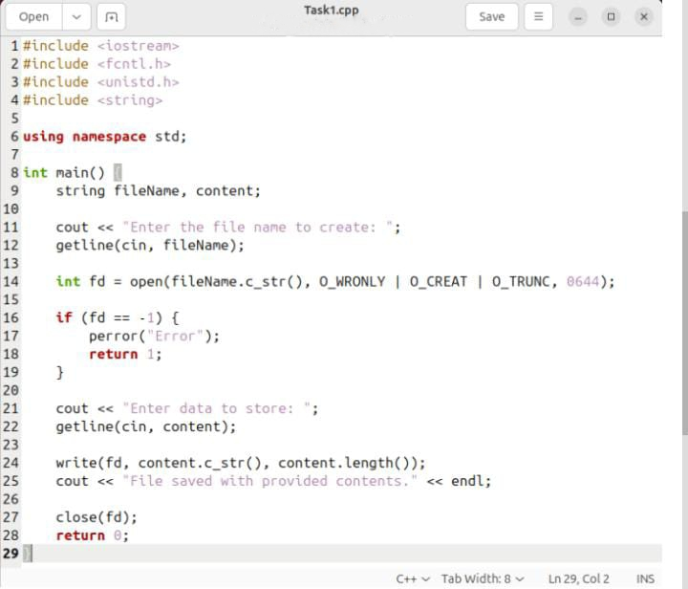

Task 2 (10 marks)
Write a C++ program which takes names of two files, i.e. file_name_1 and file_name_2. Copy the contents of the first file into the second file. Demonstrate your program using Makefile utility.
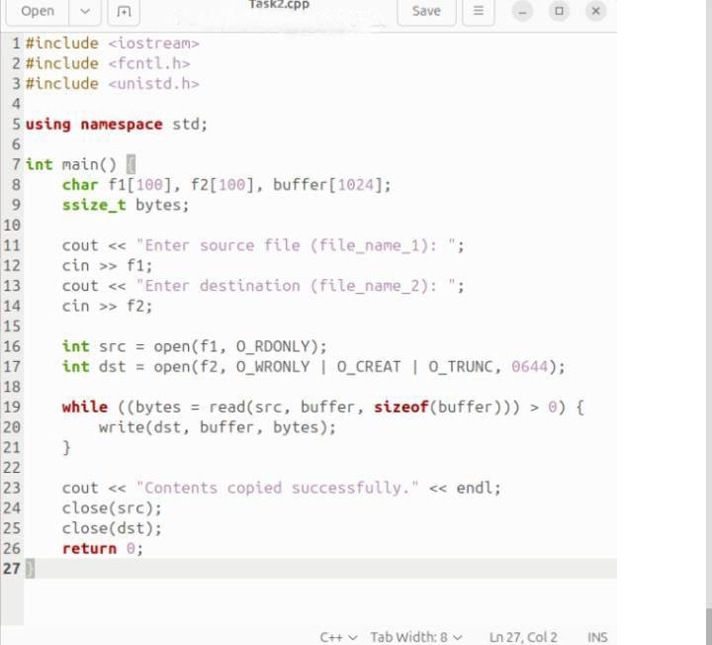

Task 3 (10 marks)
Write a C++ program which calls fork function 2 times in main function. Print process ID of each child process using getpid function. Explore the manual of getpid function and use it.
